**2019-2020**

**BANGALORE UNIVERSITY**

**BANGALORE**



**A Project Report on**

AGROTECH FARMS

Submitted for partial fulfillment of the requirement of the Mini Project Lab(MCA506P) for

MASTER OF COMPUTER APPLICATIONS

Submitted by

**BAALIREDDIPALLI SHIVA (18B6SLC002)**

**MACHAVOLU SAI KIRAN (18B6SLC008)**

Name of Guide

**Mrs. Bhargavi K**

**Asst. Professor**

**Depart of MCA**



Krupanidhi Group of Institutions

Affiliated To Bangalore University

ChikkaBellandur, Carmelaram Post, VarthurHobli

Bangalore-560035

**Krupanidhi Group of institutions**



**certificate**

This is to certify that the report entitled “**AGROTECH FARMS”** embodies the original work by **SHIVA B (18B6SLC002), SAI KIRAN M(18B6SLC008)** the partial fulfilment of the requirements for Mini Project Lab (**MCA506P**) for MCA, Vth Semester course during the academic semester from August 2019 to January 2020 as prescribed by Bangalore University.

**Project Guide Head of the Department**

**Bhargavi K**

**Place:**

**Date:**

**Krupanidhi Group of institutions**



**certificate**

This is to certify that the report entitled “**AGROTECH FARMS”** embodies the original work by **SHIVA B(18B6SLC002), SAI KIRAN M(18B6SLC008)** the partial fulfilment of the requirements for Mini Project Lab (**MCA506P** ) for MCA,V th Semester course during the academic semester from August 2019 to January 2020 as prescribed by Bangalore University.

**External Examiner**

**1._____________________**

**2._____________________**

**Place:**

**Date:**

|  |  |  |
| --- | --- | --- |
| S.no | Content | Page No |
|  | ACKNOWLEDGEMENT | 5 |
| 1 | ABSTRACT | 6 |
| 2 | PROBLEM DEFINITION | 6 |
| 3 | REQUIREMENT ANALYSIS  3.0 EXISTING SYSTEM  3.1 REQUIREMENT SPECIFICATION  3.2 HARDWARE AND SOFTWARE REQUIREMENTS | 6  7  8 |
| 4 | SYSTEM DESIGN  4.1 USE CASE DIAGRAM  4.2 CLASS DIAGRAM  4.3 OBJECT DIAGRAM  4.4 ER DIAGRAM  4.5 DATA FLOW  4.6 LIST OF TABLES | 9  10  11  12  13  14  15 |
| 5 | CODING  5.1 SOURCE CODE  5.2 SCREEN SHOTS | 16-25  26-31 |
| 6 | TESTING   1. TEST CASE1 Login Form   6.1TEST CASE2 Register  6.2TEST CASE3 Add Inventory  6.3TEST CASE3 shopping cart | 32-33 |
| 7 | CONCLUSION | 34 |
| 8 | REFERENCES | 35 |

**Table of content:**

# Acknowledgement

We would like to express our special thanks and gratitude towards The **“Krupanidhi Group of Institutions”** and the Faculty of **“MCA Department”** in the process of completion of this project.

Our special Thanks to the **Head of Department** of MCA Department “**Mrs. Priya Thomas**” and the **Project Guide** “**Mrs. Bhargavi k**” for their encouragement and support in the completion of the Project.

# Abstract: -

This project aims at creation of a platform where Agriculture use Technology. This is an approach to provide an opportunity to the Farmers to gain the Knowledge as well the Profit by interacting with Agents. This is a medium where the Consumers can request for the Products. The Agent act as a medium between the Farmers & Consumers, Thus the Farmers can gain the Profit by fulfilling the Consumer needs. This Project can be useful for Farmers without the involvement of third-party Consumers in case of Products & Transactions. This project is an internet based computerized approach towards Agricultural Product exchange.

# Problem Definition

The major concern in the Agricultural field is exchange of the products. There are many remote farmers those who farm & grow the products with high investment and they were facing problems to sell the yield in the market with low prices due to the involvement of third-party business people. Business people purchase the product with less cost, and store the yield in the cold storage. When Demand increase the yield, they going to sell the product, and make more profit.

* **Existing system:**

In the traditional approach, farmer will approach the consumer place with the yield, cost was fix by the consumer. Consumer will store the yield in the cold storage by using fertilizers and preservatives to get rid of this process, the project helps in growing the products without any fertilizers and preservatives. In this system there is no one-handed fixing of cost. The cost will be fixed based on the products.

# Requirement Analysis

Analysis is the detailed study of the various operations performed by a system and their relationships within and outside of the system. A key question is: What must be done to solve the problem? One aspect of analysis is defining the boundaries of the system and determining whether or not the user should consider other related systems. During analysis, data are collected on the available files, decision points and transactions handled by the present system.

# Requirement Specification:

In requirements specification, a deep detail about the application is briefed. If a person is new user, they can register and login to the application. The Login module validates if the user is already registered or not. If not, additional options are available on the register page, the user has to fill the given details like name, Email, contact and some more additional details varies from different kinds of users then the submission of the form stores the details in the database. After registering if the users are Agents, they will have some specific tasks like Farmer Registration, Crop Registration, Educating Farmers etc; and if the users are Consumers, they can order for the crop if it is available or they can request for Crop or Products. the Users can logout from the application by logging out option

# Hardware and Software Requirements

**Software Specification**

* + **Programming Language:** Python, JavaScript
  + **Web Framework:** Django
  + **IDE:** PyCharm
  + **Database:** Sql Lite
  + **Front-End-Web Technology:** HTML, CSS.

**Hardware Specifications**

* + **Processor:** Intel Core I3, 2.40 GHz
  + **Ram:** 4.00 GB
  + **System Type:**32-bit Operating System

**Python:**

Python is a widely used high-level programming language for general-purpose programming, created by Guido van Rossum and first released in 1991.An interpreted language, Python has a design philosophy that emphasizes code readability (notably using whitespace indentation to delimit code blocks rather than curly brackets or keywords), and a syntax that allows programmers to express concepts in fewer lines of code than might be used in languages such as C++ or Java.

It provides constructs that enable clear programming on both small and large scales. Python features a dynamic type system and automatic memory management. It supports multiple programming paradigms, including object-oriented, imperative, functional and procedural, and has a large and comprehensive standard library. Python interpreters are available for many operating systems. CPython, the reference implementation of Python, is open source software and has a community-based development model, as do nearly all of its variant implementations. CPython is managed by the non-profit Python Software Foundation.

**Django:**

Django is a free and open-source web framework, written in Python, which follows the model-view-template (MVT) architectural pattern. It is maintained by the Django Software Foundation (DSF), an independent organization established as a 501 non-profit. Django’s primary goal is to ease the creation of complex, database-driven websites. Django emphasizes reusability and "pluggability" of components, rapid development, and the principle of don't repeat yourself. Python is used throughout, even for settings files and data models. Django also provides an optional administrative create, read, update and delete interface that is generated dynamically through introspection and configured via admin models. Some well-known sites that use Django include the Public Broadcasting Service, Instagram, Mozilla, The Washington Times, Discus, Bitbucket, and Next-door. It was used on Pinterest, but later the site moved to a framework built over Flask.

**Html:**

HTML (Hypertext Markup Language) is a text-based approach to describing how content contained within an HTML file is structured. This markup tells a web browser how to display text, images and other forms of multimedia on a webpage.

HTML is a formal recommendation by the World Wide Web Consortium (W3C) and is generally adhered to by all major web browsers, including both desktop and mobile web browsers. HTML5 is the latest version of the specification.

Using HTML, a document containing text is further marked up with additional text describing how the document should be displayed. To keep the markup part, separate from the actual content of the HTML file, there is a special, distinguishing HTML syntax that is used. These special components are known as HTML tags. The tags can contain name-value pairs known as attributes, and a piece of content that is enclosed within a tag is referred to as an HTML element. An HTML element always has an opening tag, content in the middle and a closing tag. Attributes can provide additional information about the element and are included in the opening tag. Elements can be described in one of two ways

**CSS:**

Stands for "Cascading Style Sheet." Cascading style sheets are used to format the layout of Web pages. They can be used to define text styles, table sizes, and other aspects of Web pages that previously could only be defined in a page's HTML.

CSS helps Web developers create a uniform look across several pages of a Web site. Instead of defining the style of each table and each block of text within a page's HTML, commonly used styles need to be defined only once in a CSS document. Once the style is defined in cascading style sheet, it can be used by any page that references the CSS file. Plus, CSS makes it easy to change styles across several pages at once. For example, a Web developer may want to increase the default text size from 10pt to 12pt for fifty pages of a Web site. If the pages all reference the same style sheet, the text size only needs to be changed on the style sheet and all the pages will show the larger text.

**MySQL:**

MySQL is an Oracle-backed open source relational database management system (RDBMS) based on Structured Query Language (SQL). MySQL runs on virtually all platforms, including Linux, UNIX and Windows. Although it can be used in a wide range of applications, MySQL is most often associated with web applications and online publishing. MySQL is an important component of an open source enterprise stack called LAMP. LAMP is a web development platform that uses Linux as the operating system, Apache as the web server, MySQL as the relational database management system and PHP as the object-oriented scripting language. (Sometimes Perl or Python is used instead of PHP.)Originally conceived by the Swedish company MySQL AB, MySQL was acquired by Sun Microsystems in 2008 and then by Oracle when it bought Sun in 2010. Developers can use MySQL under the GNU General Public License (GPL), but enterprises must obtain a commercial license from Oracle.Today, MySQL is the RDBMS behind many of the top websites in the world and countless corporate and consumer-facing web-based applications, including Facebook, Twitter and YouTube.

# System Design

Design is a meaningful engineering and creative process; a good design is the key to effective system. The Systems design is the process of defining the architecture, modules, interfaces, and data for a system to satisfy specified requirements. Systems design could be seen as the application of systems theory to product development. There is some overlap with the disciplines of systems analysis, systems architecture and systems engineering. Systems design implies a systematic approach to the design of a system. It may take a bottom-up or top-down approach, but either way the process is systematic wherein it takes into account all related variables of the system that needs to be created—from the architecture, to the required hardware and software, right down to the data and how it travels and transforms throughout its travel through the system. Systems design then overlaps with systems analysis, systems engineering and systems architecture. The systems design approach first appeared right before World War II, when engineers were trying to solve complex control and communications problems. They needed to be able to standardize their work into a formal discipline with proper methods, especially for new fields like information theory, operations research and computer science in general.

**4.0 USECASE DIAGRAM**

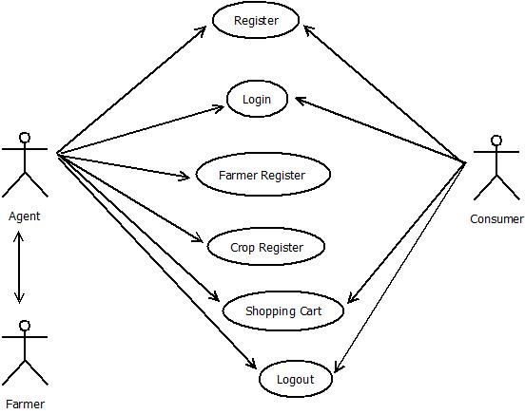

**4.2 CLASS DIAGRAM**

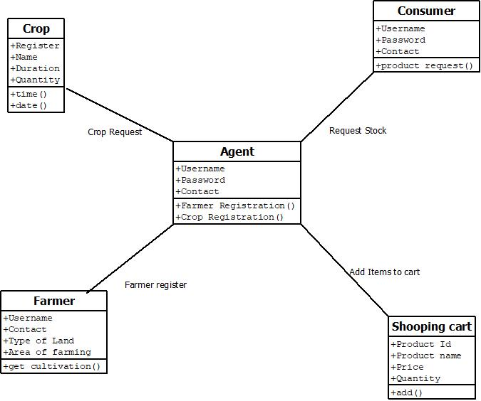

**4.2 ER Diagram:**

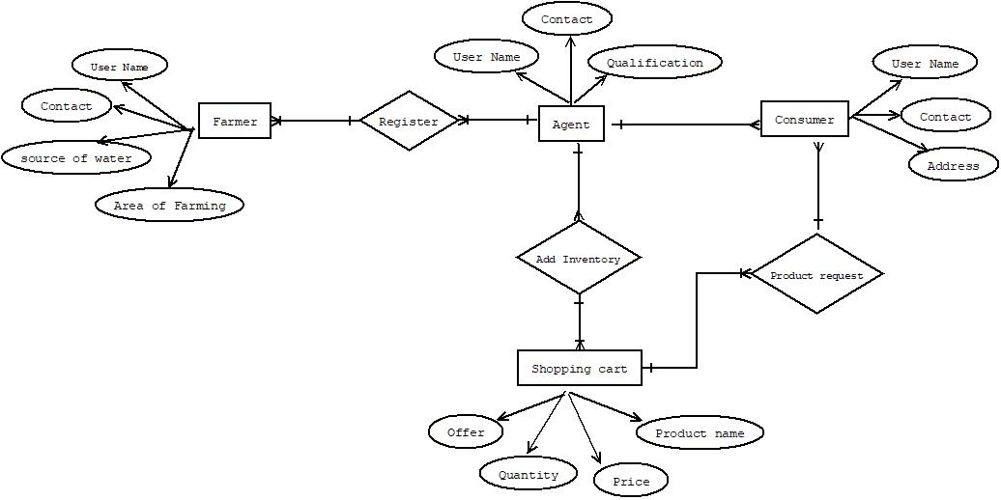

**4.3 OBJECT DIAGRAM**

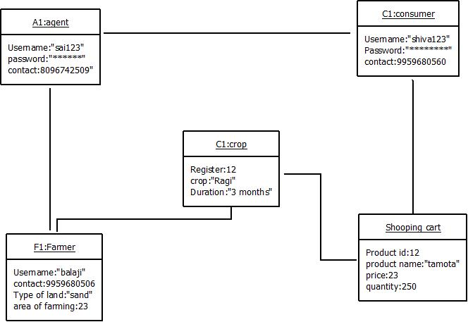

**4.4 Data Flow Diagram**

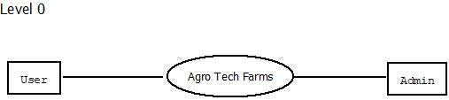

Level 1

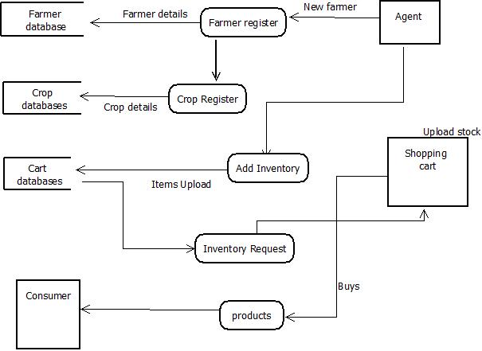

**4.5 List of Tables:**

**Table name:** User details:

**Description:** To store Agent and consumer details.

|  |  |  |
| --- | --- | --- |
| Name | Type | Key |
| User name | Char Field | Primary key |
| Email | EmailField |  |
| Address | TextField(200) |  |
| DOB | DateField |  |
| Gender | CharField(2) |  |
| Pincode | integerField |  |

**Table name:** Farmer details:

**Description:** To store farmer details.

|  |  |  |
| --- | --- | --- |
| Name | Type | Key |
| Farmer ID | Integer Field | Primary key |
| Farmer name | TextField(50) |  |
| Address | TextField(200) |  |
| DOB | DateField |  |
| Gender | CharField(50) |  |
| Total land | integerField |  |
| Pincode | IntegerField |  |

**Table name:** Crop details:

**Description:** To store farmer crop details.

|  |  |  |
| --- | --- | --- |
| Name | Type | Key |
| Farmer ID | Integer Field | foreign key |
| Crop ID | Integer Field |  |
| Crop Name | TextField(200) |  |
| Area of farming | IntegerField |  |
| Crop planted date | DateField |  |
| Crop duration | IntegerField |  |
| Pincode | IntegerField |  |

# 5.Coding

**a) Url.py**

**Here have to store all our URL-patterns of our project. For every view (web page) and have to define separate URL-pattern. End user can use URL-patterns to access our webpages.**

from django.urls import path

from .import views

urlpatterns=[

path('',views.home,name='home'),

path('Login',views.Loginpage,name='Loginpage'),

path('div',views.divpage,name='divpage'),

path('consumer',views.consumerpage,name='conspage'),

path('agent',views.agentpage,name='agentpage'),

path('contactus',views.contactus,name='contactus'),

path('aboutus',views.aboutus,name='aboutus'),

path('Cart1',views.CartPage,name='cartpage'),

path('cropreg',views.cropregi,name='repeat1'),

path('Farmer',views.farmerreg,name='farmer1'),

path('agent',views.agentsignup,name='signup'),

path('consumer',views.consumersignup,name='signup'),

path('feedback',views.feedbackp,name='feedbackp'),

path('Cart2',views.Addelements,name='Addelements'),

path('Cart3',views.ItemsCart,name='ItemsCart'),

path('Login1',views.login,name='login'),

path('Thankyou',views.Thankyou1,name='Thankyou'),

path('homeback',views.backpage,name='bakcpage'),

path('logout1',views.logout1,name='logout1'),

path('farmerf',views.fetchfarmer,name='fetchfarmer'),

path('agentf',views.fetchagent,name='agent'),

path('consumerf',views.fetchconsumer,name='fetchconsumer'),

path('contactFetch',views.fetchcontact,name='fetchcontact'),

path('feedback1',views.Feedback1,name='feedback1'),

path('crop',views.cropfetch,name='cropfetch'),

path('Bagitems',views.Checkout,name='Checkout'),

path('Cartsignup',views.CartSignup,name="CartsignUp"),

path('CartLogin',views.CartLogin,name='CartLogin'),

path('checkout',views.itemout,name='itemout'),

path('CartSignup',views.Cartsignup,name='Cartsignup'),

path('delete',views.Removeitems,name='Removeitems'),

]

**b) Views .py: -**

**This file have to save functions that handles requests and return required responses.**

from django.shortcuts import render

from django.http import HttpResponse

#from django.http import HttpResponseRedirect

from django.contrib.auth.models import User,auth

from django.contrib.auth import login,logout,authenticate

from django.contrib import messages

from .models import FarmerRegister

from .models import CropRegister

from.models import Contact_us

from.models import AgentInfo

from.models import ConsumerInfo

from.models import Feedback

from.models import Add_Items

from.models import Seconddata

from.models import checkout

from.models import CartUser

from.models import Seconddata

# write funcions

def home(request):

return render(request,'Home.html')

def Loginpage(request):

return render(request,'login.html')

def divpage(request):

return render(request,'Div.html')

def aboutus(request):

return render(request,'aboutUs.html')

def contactus(request):

if request.method=="POST":

Fname = request.POST['Fname']

Lname = request.POST['Lname']

email1 =request.POST['Email']

textf = request.POST['texta']

contacts=Contact_us(Fname=Fname,Lname=Lname,email1=email1,textf=textf)

contacts.save()

return render(request,'welcome.html')

else:

return render(request,'contactus.html')

def consumerpage(request):

return render(request,'Consumersign.html')

def agentpage(request):

return render(request,'AgentSignup.html')

def CartPage(request):

data1=Add_Items.objects.all()

Allitems = checkout.objects.all()

cartsize = len(Allitems)

return render(request,'Cart.html',{'name':data1,'cart':cartsize})

def Addelements(request):

return render(request,'Addcart.html')

def backpage(request):

return render(request,'Home.html')

def ItemsCart(request):

if request.method=='POST'and request.FILES['PFile']:

ProductId=request.POST['PID']

ProductName=request.POST['PName']

ProductImage=request.FILES['PFile']

FarmerDetails=request.POST['PFarmer']

Contact_info=request.POST['PInfo']

Quantity=request.POST['Total']

Price=request.POST['PPrice']

Addcart=Add_Items(ProductId=ProductId,ProductName=ProductName,ProductImage=ProductImage,FarmerDetails=FarmerDetails,Contact_info=Contact_info,Quantity=Quantity,

Price=Price)

Addcart.save()

return render(request,'second.html')

else:

return render(request,'Addcart.html')

def feedbackp(request):

if request.method=='POST':

Rating=request.POST.get('experience')

Comments=request.POST['comments']

Name=request.POST['name']

Email=request.POST['email']

feedbackT=Feedback(Rating=Rating,Comments=Comments,Name=Name,Email=Email)

feedbackT.save()

return render(request,'Cart.html')

else:

return render(request,'feedback.html')

def farmerreg(request):

if request.method == 'POST' and request.FILES['pic']:

Regnumber = request.POST['NName']

Fname = request.POST['FName']

Lname = request.POST['LName']

Bdate = request.POST['bday']

#Uname = request.POST['UName']

Email = request.POST['EId']

Mobile = request.POST['Mnumber']

Gender = request.POST.get('Gender')

Address = request.POST['Address']

City = request.POST['City']

Pincode = request.POST['Pcode']

State = request.POST['State']

Country = request.POST['Country']

Tland = request.POST['Landm']

upimage = request.FILES['pic']

Ctype = request.POST['Ncrop']

farmer = FarmerRegister(Regnumber=Regnumber, Fname=Fname, Lname=Lname, Bdate=Bdate,Email=Email,Mobile=Mobile, Gender=Gender, Address=Address, City=City,

Pincode=Pincode, State=State, Country=Country, Tland=Tland, upimage=upimage,Ctype=Ctype)

farmer.save()

return render(request, 'Second.html')

else:

return render(request,'farmer.html')

def cropregi(request):

if request.method == "POST":

FarmerR = request.POST['number']

CropI = request.POST['ciname']

CropN = request.POST['cnname']

Area = request.POST['aname']

Typesoil = request.POST['soil']

WaterS = request.POST['wname']

Sdate = request.POST['date']

Edate = request.POST['Edate']

Loanreq = request.POST.get('loan')

Ferreq = request.POST.get('pesticides')

Chec = request.POST.get('har')

g=FarmerRegister.objects.get(Regnumber=FarmerR)

crop = CropRegister(farmerRegister=g, CropI=CropI, CropN=CropN, Area=Area, Typesoil=Typesoil, WaterS=WaterS, Sdate=Sdate, Edate=Edate, Loanreq=Loanreq,Ferreq=Ferreq, Chec=Chec)

crop.save()

return render(request, 'second.html')

else:

return render(request, 'Crop Register.html')

def agentsignup(request):

if request.method=='POST':

Fname=request.POST['Fname']

Lname=request.POST['Lname']

Email=request.POST['Email']

Gender=request.POST.get('gender')

Qualification=request.POST['qualification']

Ddate=request.POST['ddate']

IDproof=request.POST['Iname']

Address=request.POST['region']

Pincode=request .POST['Pname']

Password=request.POST['password1']

Cpassword=request.POST['password2']

if User.objects.filter(email=Email).exists():

messages.info(request,'Email already Taken')

return render(request,'AgentSignup.html')

else:

user = User.objects.create_user(username=Email,first_name=Fname,last_name=Lname,password=Password,email=Email)

agentsign=AgentInfo(Fname=Fname,Lname=Lname,Email=Email,Gender=Gender,Qualification=Qualification,Ddate=Ddate,IDproof=IDproof,Address=Address,

Pincode=Pincode)

agentsign.save()

return render(request,'login.html')

else:

return render(request,'Div.html')

def consumersignup(request):

if request.method=='POST':

Fname=request.POST['Fname']

Lname=request.POST['Lname']

Email=request.POST['Email']

Gender=request.POST.get('gender')

Qualification=request.POST['qualification']

Ddate=request.POST['ddate']

IDproof=request.POST['Iname']

Address=request.POST['region']

Pincode=request.POST['Pname']

Password=request.POST['password1']

Cpassword = request.POST['password2']

if User.objects.filter(email=Email).exists():

messages.info(request,'Email already Taken')

return render(request, 'Consumersign.html')

user = User.objects.create_user(username=Email, first_name=Fname, last_name=Lname, password=Password,email=Email)

consumersign=ConsumerInfo(Fname=Fname,Lname=Lname,Email=Email,Gender=Gender,Qualification=Qualification,Ddate=Ddate,IDproof=IDproof,Address=Address,

Pincode=Pincode)

consumersign.save()

return render(request,'login.html')

else:

return render(request,'Div.html')

def Thankyou1(request):

desc = Seconddata.objects.all()

return render(request,'second.html',{'news':desc})

def login(self):

if self.method=='POST':

username=self.POST['Uname']

password=self.POST['password']

user=auth.authenticate(username=username,password=password)

if user is not None:

auth.login(self,user)

return render(self,'second.html',{'un':username})

else:

return render(self,'login.html' )

else:

return render(self, 'Home.html')

def logout1(request):

auth.logout(request)

return render(request,'Home.html')

def fetchfarmer(request):

Allfarmers=FarmerRegister.objects.all()

return render(request,'FetchFarmer.html',{'farmers':Allfarmers})

def fetchagent(request):

AllAgent=AgentInfo.objects.all()

return render(request,'AgentFetch.html',{'agent':AllAgent})

def fetchconsumer(request):

AllConsumer=ConsumerInfo.objects.all()

return render(request,'Consumerfetch.html',{'consumer':AllConsumer})

def fetchcontact(request):

Allcontact=Contact_us.objects.all()

return render(request,'contactfetch.html',{'contact':Allcontact})

def Feedback1(request):

Allfeedback=Feedback.objects.all()

return render(request,'Feedbackfetch.html',{'feedback':Allfeedback})

def cropfetch(request):

Allcrop=CropRegister.objects.all()

return render(request,'cropfetch.html',{'crop':Allcrop})

def Checkout(request):

if request.method=="POST":

ProductId=request.POST['productno']

Productprice=request.POST['price1']

ProductName=request.POST['pname']

items=checkout(ProductId=ProductId,ProductName=ProductName,Productprice=Productprice)

items.save()

ItemsinBag=Add_Items.objects.all()

Allitems = checkout.objects.all()

cartsize = len(Allitems)

return render(request,'Cart.html',{'name':ItemsinBag,'cart':cartsize})

else:

return render(request, 'Crop Register.html')

def itemout(request):

Allitems=checkout.objects.all()

return render(request,'checkout.html',{'items':Allitems})

def CartSignup(request):

return render(request,"CartsignUp.html")

def CartLogin(request):

return render(request,"CartLogin.html")

def Removeitems(request,ProductId):

k=checkout.objects.get(ProductId=ProductId)

k.delete()

return render(request,"checkout.html")

def Cartsignup(request):

if request.method=='POST':

Fname=request.POST['Name']

Email=request.POST['email']

Address=request.POST['Address']

Pass=request.POST['psw']

Cpass= request.POST['psw-repeat']

if User.objects.filter(email=Email).exists():

messages.info(request,'Email already Taken')

return render(request,'Cartsignup.html')

user = User.objects.create_user(username=Email, first_name=Fname, password=Pass)

sign=CartUser(UserName=Fname,Email=Email,Address=Address)

sign.save()

k = Add_Items.objects.all()

return render(request,'Cart.html',{'name':k})

else:

return render(request,'CartSignup.html')

def CartLogin(self):

if self.method=='POST':

username=self.POST['email']

password=self.POST['psw']

user=auth.authenticate(username=username,password=password)

if sign is not None:

auth.login(self,sign)

return render(self,'checkout.html',{'un':username})

else:

return render(self,'checkout.html' )

else:

return render(self, 'Home.html')

**c) Models.py:-**

**this file is used to store application's data models.**

from django.db import models

# Create your models here.

class Contact_us(models.Model):

Fname=models.CharField(max_length=30)

Lname=models.CharField(max_length=30)

email1=models.EmailField(max_length=30)

textf=models.EmailField(max_length=30)

class AgentInfo(models.Model):

Fname=models.CharField(max_length=30)

Lname=models.CharField(max_length=30)

Email=models.CharField(max_length=30)

Gender=models.CharField(max_length=30)

Qualification=models.CharField(max_length=30)

Ddate=models.DateField(max_length=30)

IDproof=models.CharField(max_length=30)

Address=models.CharField(max_length=100)

Pincode=models.IntegerField(default=0)

class ConsumerInfo(models.Model):

Fname = models.CharField(max_length=30)

Lname = models.CharField(max_length=30)

Email = models.CharField(max_length=30)

Gender = models.CharField(max_length=30)

Qualification = models.IntegerField()

Ddate = models.DateField(max_length=30)

IDproof = models.CharField(max_length=30)

Address = models.CharField(max_length=100)

Pincode=models.IntegerField(default=None)

class Add_Items(models.Model):

ProductId=models.IntegerField(default=None,primary_key=True)

ProductName=models.CharField(max_length=30)

ProductImage=models.FileField(upload_to='documents/')

FarmerDetails = models.CharField(max_length=30)

Contact_info = models.CharField(max_length=30)

Quantity=models.IntegerField(default=None)

Price = models.FloatField()

class Feedback(models.Model):

Rating=models.CharField(max_length=30)

Comments=models.CharField(max_length=30)

Name=models.CharField(max_length=30)

Email=models.CharField(max_length=30)

class FarmerRegister(models.Model):

Regnumber=models.IntegerField(default=None,primary_key=True)

Fname=models.CharField(max_length=30)

Lname=models.CharField(max_length=30)

Bdate=models.DateField()

#Uname=models.CharField(max_length=30)

Email=models.EmailField()

Mobile=models.IntegerField()

Gender=models.CharField(max_length=30)

Address=models.CharField(max_length=30)

City=models.CharField(max_length=30)

Pincode=models.IntegerField()

State=models.CharField(max_length=30)

Country=models.CharField(max_length=30)

Tland=models.IntegerField()

upimage=models.FileField(upload_to='documents/')

Ctype=models.CharField(max_length=30)

class CropRegister(models.Model):

farmerRegister=models.ForeignKey(FarmerRegister, on_delete=models.CASCADE)

CropI=models.IntegerField()

CropN=models.CharField(max_length=30)

Area=models.FloatField()

Typesoil=models.CharField(max_length=30)

WaterS=models.CharField(max_length=30)

Sdate=models.DateField(auto_now_add=True)

Edate=models.DateField()

Loanreq=models.CharField(max_length=30)

Ferreq=models.CharField(max_length=30)

Chec=models.CharField(max_length=30,default='0')

class Seconddata(models.Model):

Today=models.CharField(max_length=30)

Head=models.CharField(max_length=250)

img=models.CharField(max_length=250)

quote=models.CharField(max_length=250)

subquote=models.CharField(max_length=250)

class checkout(models.Model):

ProductId=models.IntegerField(default=None,primary_key=True)

ProductName=models.CharField(max_length=30,default='0')

Productprice= models.FloatField(default=None)

class CartUser(models.Model):

UserName=models.CharField(max_length=30,default='0')

Email=models.EmailField()

Address=models.CharField(max_length=30)

# 5.1 Main modules

a. User

b. Farmer

c. Shopping cart

**a) User module**

This Allows User to register. They are two type of users Agent and Consumer. Agent work to full fill the consumer and farmer needs.

* Email
* User Name
* Qualification
* Address

**b) Farmer Module:**

In this module, Farmer register was done by the Agent , Agent act as the mediator between the farmer and consumer, Based on the consumer requirements agent will register farmers crop.

* Farmer Register
* Contact
* Area of Farming
* Water source

**c) Shopping cart**:

Based on stock availability, agent upload the products to shopping cart. Traders can buy the stock from the Cart.

* Crop Id
* Product Name
* Product Price
* Quantity

# 5.2 Screen shots

**a) Index page:**

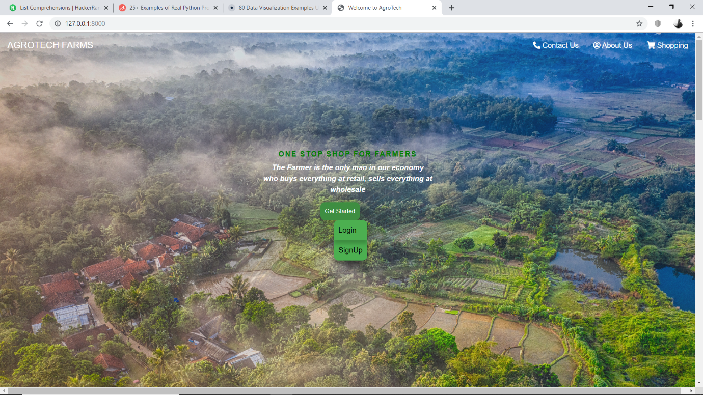

**b) Login form:**

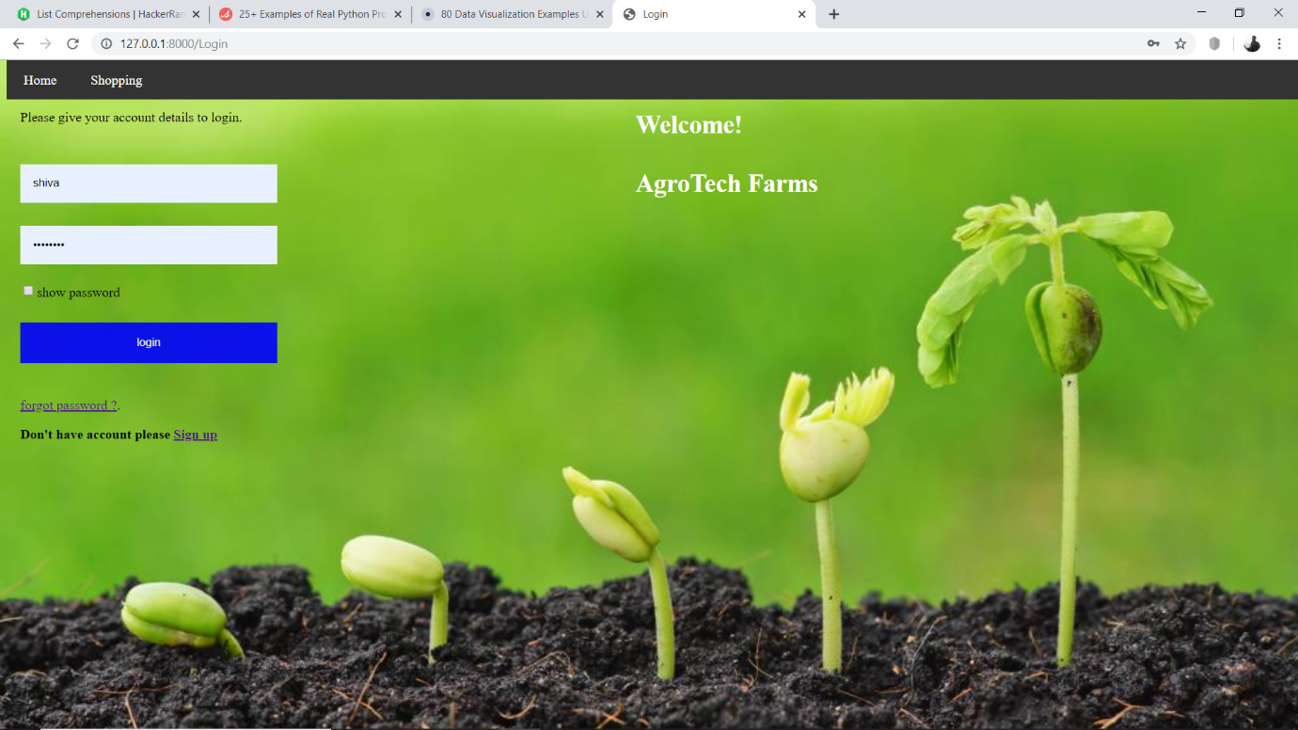

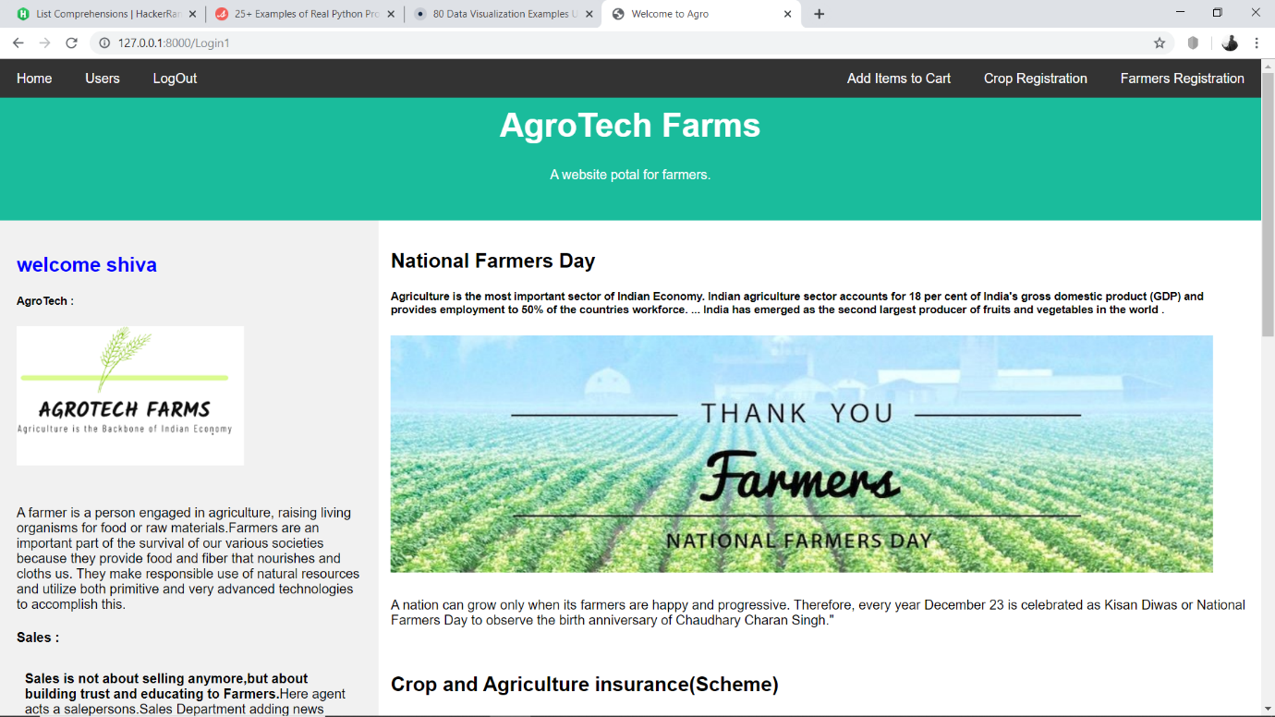

**c) Registration Form:**

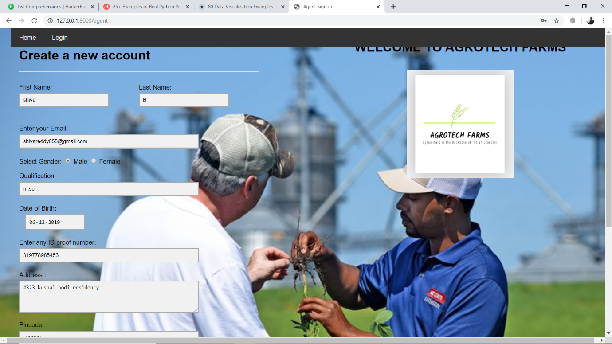

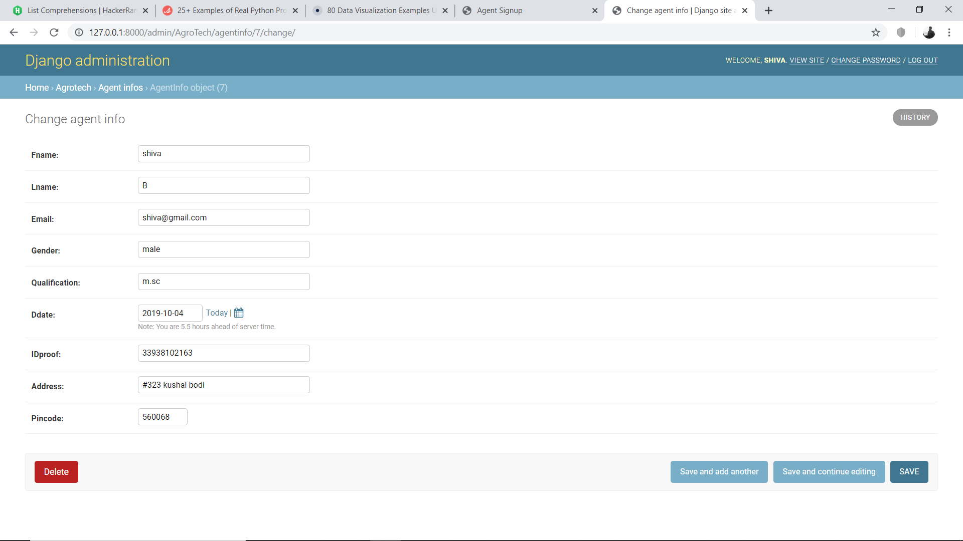

**d) Farmer Register:**

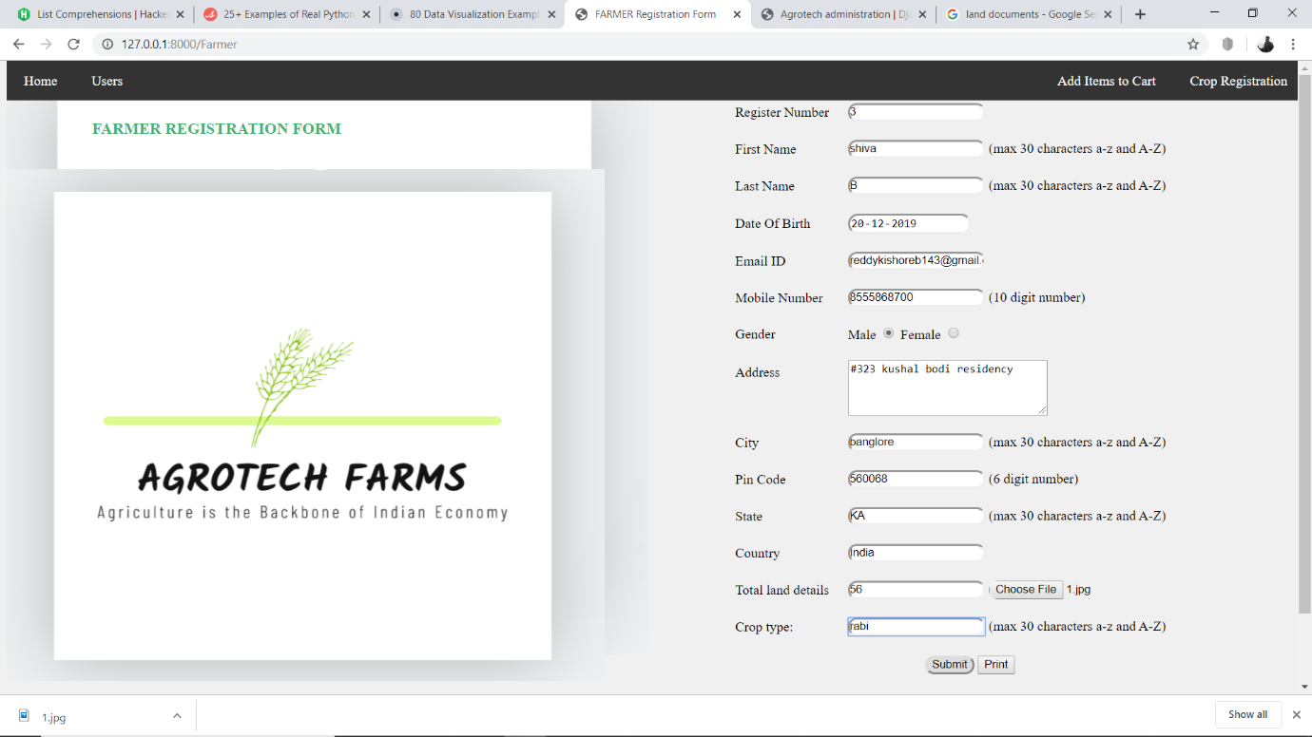

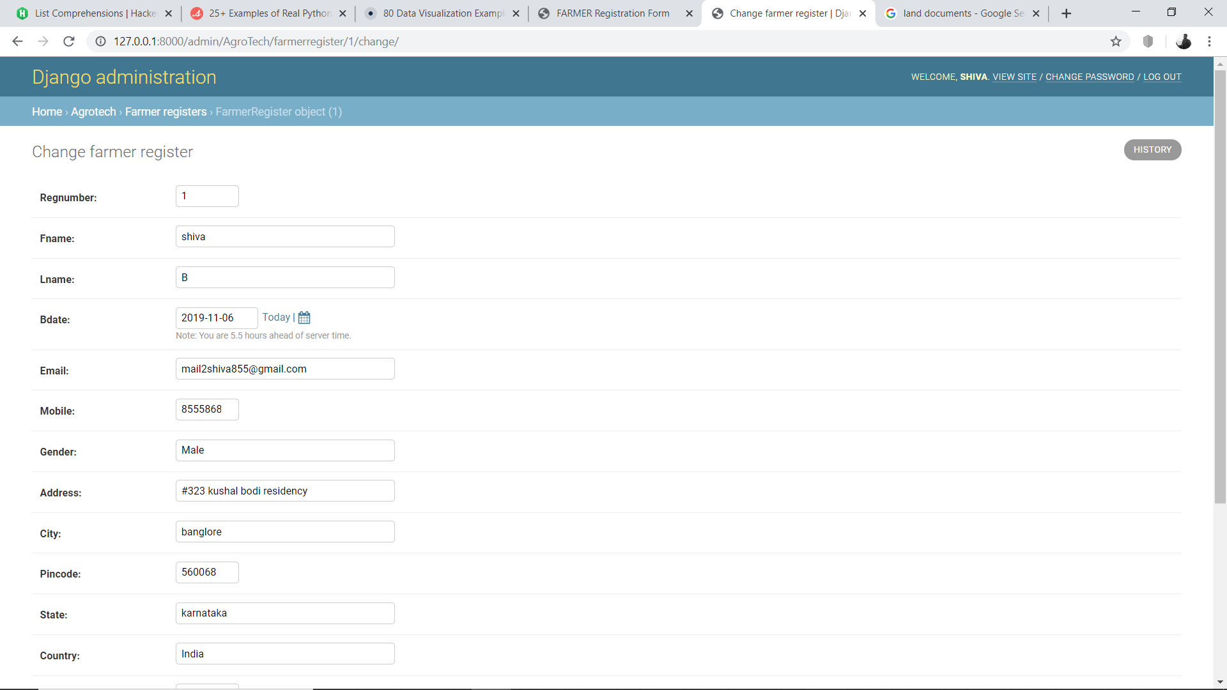

**e) Crop Register:-**

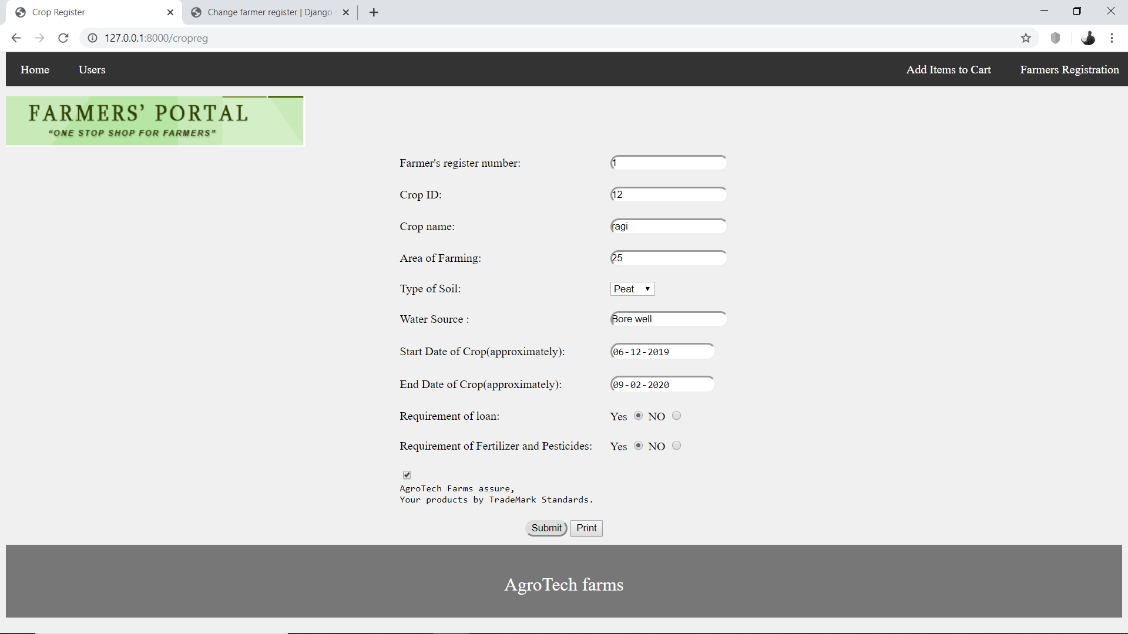

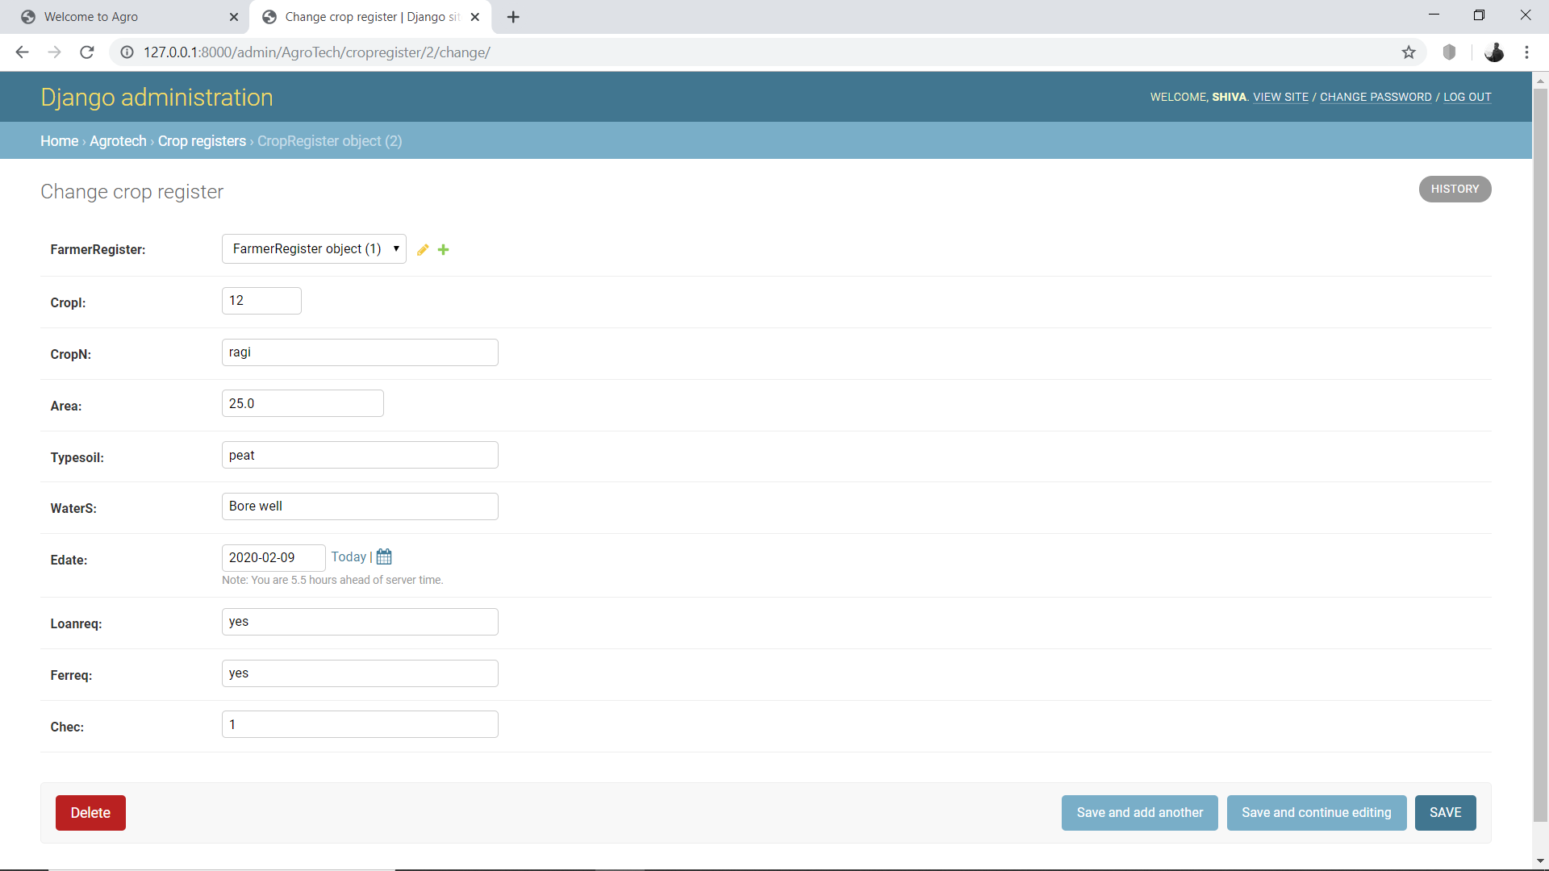

**f) Shopping Cart:**

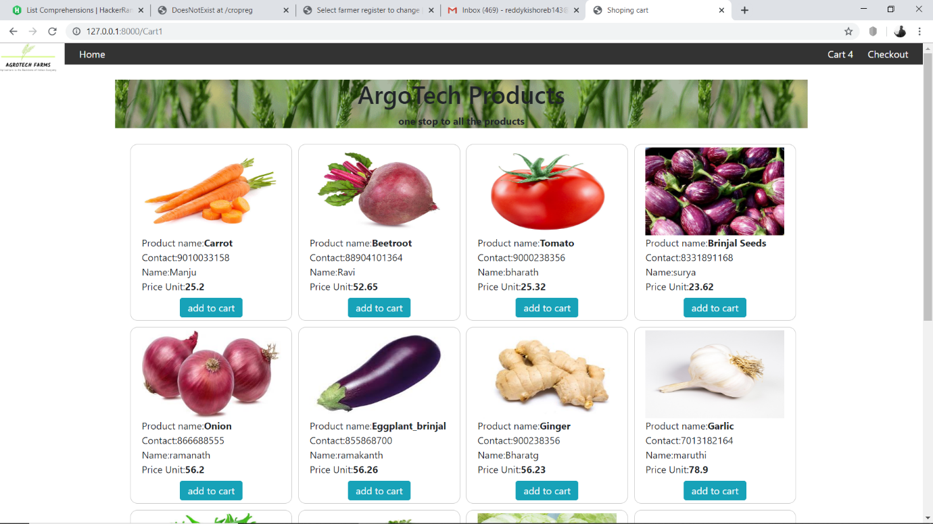

**g) Checkout:-**

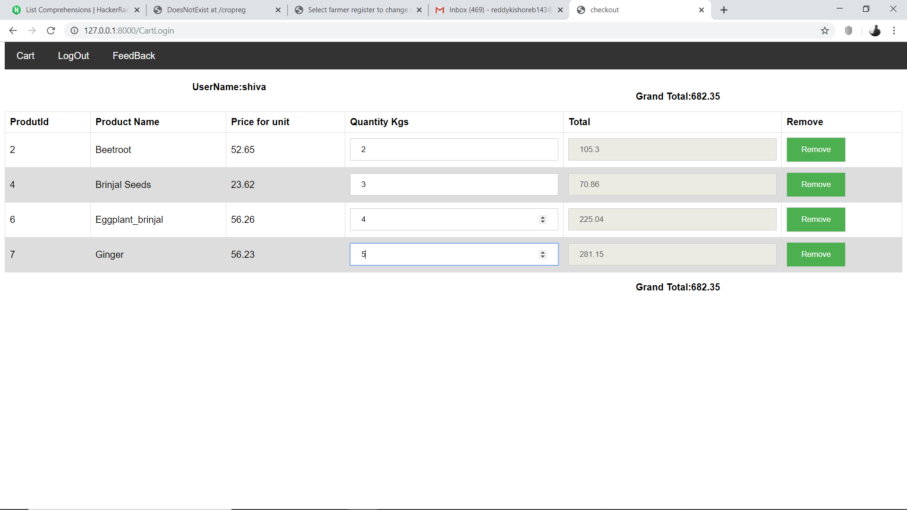

# 6. Testing

# 6.0 Test Case 1: Login Form

Description:-

* Only Existing users can login.

Preparation:-

* First user id is entered
* Second password is entered.

Execution:-

* After logged in, access is granted
* Logout.

Check:-

* Check whether we can still access the uploads after logout
* Check whether we can see the user information logged in

# 6.1Test Case 2: Register

Description:-

* Only after register user can login.

Preparation:-

* User name is entered
* Gmail is entered
* Mobile number id is entered

Execution:-

* After registration, admin will verify and give permission to access

Check:

* Check whether we can still access user information after register
* Check whether we can see the user information logged in

# 6.2 Test Case 3: User page:

Description:-

* Only Existing users can login.

Preparation:-

* First user id is entered
* Second password is entered.

Execution:-

* After login,admin can see the register user and farmer details.

Check:

* Check whether user can register farmers and crop.
* Check whether can see the register details of farmer

# 6.3Test Case 4:Add Inventory:

Description:

* Agent can add items to cart.

Preparation:-

* User name is entered
* Gmail is entered
* Mobile number id is entered

Execution:-

* After register, Agent will add inventory to cart

Check:

* Check whether the items are available in shopping cart after adding the inventory.

**6.4** **Test Case 5: shopping cart**

Description:

* Only register user can login to purchase the products.

Preparation:-

* User name is entered
* Password is entered

Execution:-

* After Login, User can purchase the products.
* He can add items to cart.

Check:

* Check whether the add to cart items are available in the cart after adding the Items to cart.

**7.Conclusion:**

This Project concludes that, it is a useful platform for farmers as well the consumers for the Agricultural product exchange without the Third-party involvement. The agent plays a major role in this project. The consumer can receive the products directly form the farmers with the help of agent .This is an approach to provide an opportunity to the Farmers to gain the Knowledge as well the Profit by interacting with Agents. This project is an internet based computerized approach towards Agricultural Product exchange.

# 8.References

[www.python.org](http://www.python.org)

<https://docs.djangoproject.com/en/3.0/>

<https://www.geeksforgeeks.org/>